Clear creek county coroner’s office
Chris Hegmann, Coroner
2019
Annual report

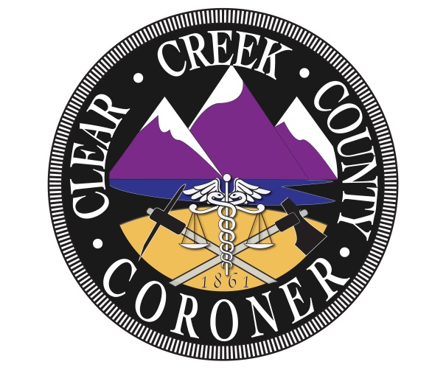

The mission of the Clear Creek County Coroner’s Office is to protect the interests of deceased individuals and the citizens of Clear Creek County by conducting independent investigations of deaths occurring within our jurisdiction. We determine the cause and manner of death, the identity of the decedent and provide notification to the legal next of kin with compassion, professionalism, and integrity.

Coroner Staff

Chris Hegmann
Coroner

Nichol Nelson
Chief Deputy Coroner

Kristi Morrell
Deputy Coroner

Nina Harquist
Deputy Coroner

Jared Hayward
Deputy Coroner

2019 Clear Creek County Deaths

Total Deaths: 68

Gender:
- Male: 49
- Female: 19

Manner:
- Natural: 44
- Accidental: 9
- Suicide: 10
- Homicide: 1
- Pending final results: 4

Natural causes:
- Cardiac: 21
  - Congestive heart failure: 5
  - Heart failure: 4
  - Coronary artery disease: 2
  - Acute myocardial infraction: 5
  - Arteriosclerotic heart disease: 2
  - Cardiomyopathy: 1
  - Acute cardio-vascular disease: 1
  - Cardiac disease in post-operative state: 1
- Cancer: 6
  - Endometrial cancer: 1
  - Lung cancer: 2
  - Pancreatic cancer: 2
  - Myeloid leukemia: 1
- Respiratory failure: 4
- Alzheimer’s: 2
- COPD: 2
- Dementia: 1
- Fetal demise: 1
- Acute subdural hematoma: 1
- Aspiration pneumonia: 2
- Progressive supranuclear palsy: 1
- Sleep apnea: 1
- Cardiorespiratory arrest: 1
- Myelodysplasia syndrome: 1

Suicide:
- Gunshot wound: 7
- Hanging: 2
- CO asphyxiation: 1

Homicide:
- Gunshot wound: 1

Accidental:
- Blunt force trauma avalanche: 1
- Blunt force trauma fall: 3
- Blunt force trauma MVA: 1
- Overdose: 1
- Sub-arachnoid hemorrhage: 1
- Meth. Toxicity: 1
- Drowning: 1

Autopsies: 11

Hospice: 21

Deaths by month:
- January: 7
- February: 3
- March: 7
- April: 8
- May: 1
- June: 5
- July: 9
- August: 5
- September: 7
- October: 9
- November: 3
- December: 4

Deaths by age:
- 0-20: 4
- 21-30: 2
- 31-40: 4
- 41-50: 5
- 51-60: 7
- 61-70: 16
- 71-80: 15
- 81-90: 13
- 91+: 2

Jurisdiction:
- Idaho Springs: 15
- Georgetown: 4
- Empire: 2
- Evergreen: 14
- Lawson: 1
- Dumont: 7
- Downieville: 1
- Silver Plume: 2
- Unincorporated CCC: 20
- Transfer: 2

Local: 50
Visitor: 18

Trends and Observations

2019 like 2018 was another year showing advance in the number of deaths in the county. 2019 was not as substantial in growth as the growth from 2017 to 2018, but we are still seeing an increase with a total of 68 deaths compared to 65.

The greatest number of natural deaths was contributed by heart disease with a total of 21 deaths. This seems to be the most common throughout the years and continues to grow. In 2018 there were 19 out of 47 whereas 2019 there were 21 out of 44 almost half of all natural deaths.

The number of suicides has grown from 8 in 2018 to 10 in 2019, as there is an increase in visitors coming to the county. 6 out of 10 of the suicides are from those that resided out of the county. Accidental deaths have increased dramatically for 2019 with a total of 9 while 2018 there were 5. The contribution to the greater number of accidental deaths had resulted in blunt force traumas. Homicide deaths unfortunately have increased from 0 in 2018 to 1 in 2019 due to a gunshot wound.

Autopsies have once again decreased with a total of 11 out of 68 in 2019 compared to 19 out of 65 in 2018. The number of hospice deaths has shown a growth from 19 to 21 deaths.

The number of female deaths has decreased from 24 in 2018 to 19 in 2019 where the number of male deaths has increased from 41 in 2018 to 49 in 2019. The percentage of visitor deaths in the county has remained constant with that from 2018.

Also to be noted that there has been a 50% growth in deaths in Unincorporated Clear Creek County from 10 in 2018 to 20 in 2019.

