Clear creek county coroner’s office
Chris Hegmann, Coroner
2020
Annual report

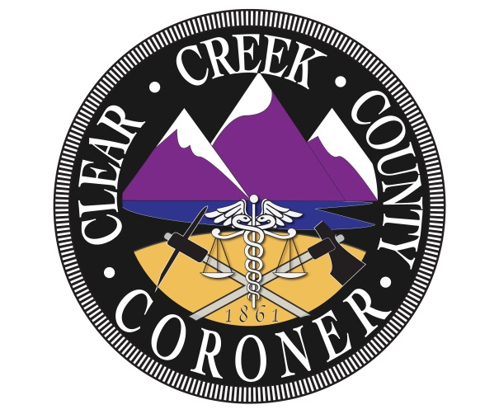

The mission of the Clear Creek County Coroner’s Office is to protect the interests of deceased individuals and the citizens of Clear Creek County by conducting independent investigations of deaths occurring within our jurisdiction. We determine the cause and manner of death, the identity of the decedent and provide notification to the legal next of kin with compassion, professionalism, and integrity.

Coroner Staff

Chris Hegmann
Coroner

Nichol Nelson
Chief Deputy Coroner

Kristi Morrell
Deputy Coroner

Nina Harquist
Deputy Coroner

Jared Hayward
Deputy Coroner

2020 Clear Creek County Deaths

Total Deaths: 62

Gender:
- Male: 39
- Female: 23

Manner:
- Natural: 46
- Accidental: 8
- Suicide: 4
- Homicide: 2- 1 Homicide was a transfer to Jefferson County
- Undetermined: 1
- Pending final results: 1

Natural causes:
- Cardiac: 14
  - Congestive heart failure: 3
  - Heart failure: 3
  - Coronary artery disease: 1
  - Arteriosclerotic heart disease: 1
  - Artherosclerotic coronary disease: 3
  - Hypertension/hyperlipidemia: 3
- Cancer: 7
  - Uterine Cancer: 2
  - Lung cancer: 2
  - Pancreatic cancer: 1
  - Ovarian carcinoma: 1
  - B cell lymphoma: 1
  - Glioblastoma: 1
- COPD: 7
- COVID-19: 1
- Sepsis: 2
- Chronic alcohol abuse: 2
- Cerebrovascular disease: 1
- Chronic kidney disease: 2
- Pulmonary hypertension: 1
- Diabetes mellitus: 1
- Community acquired pneumonia: 1
- Parkinson’s disease: 1
- Liver failure: 2
- Lennox gastaut syndrome: 1
- Sclerosis hepatic failure: 1

Suicide:
- Gunshot wound: 1
- Hanging: 2
- Stab wounds: 1

Homicide:
- Gunshot wound: 1
- Transfer to Jefferson County: 1

Accidental:
- Blunt force injuries: 4
- Overdose Fentanyl/ Fentanyl toxicity: 2
- Acute bilateral pneumonia: 1
- Drowning: 1

Autopsies: 11

Hospice: 22

Deaths by month:
- January: 1
- February: 7
- March: 2
- April: 3
- May: 6
- June: 5
- July: 6
- August: 5
- September: 11
- October: 5
- November: 8
- December: 3

Deaths by age:
- 0-20: 2
- 21-30: 4
- 31-40: 4
- 41-50: 2
- 51-60: 12
- 61-70: 13
- 71-80: 10
- 81-90: 11
- 91+: 4

Jurisdiction:
- Idaho Springs: 20
- Georgetown: 5
- Empire: 5
- Evergreen: 9
- Lawson: 1
- Dumont: 2
- Silver Plume: 3
- Unincorporated CCC: 13
- Transfer: 7

Local: 49
Visitor: 13

Trends and Observations

2020 was an odd year compared to previous years, there was still an advanced number, but it was a decrease from 2019. 2020 had a total of 62 deaths which is less than 2019 with 68 deaths; it may be believed this may have been due to the pandemic.

The greatest number of natural deaths was contributed to heart disease with a total of 14 deaths. This seems to be the most common cause throughout the years and has shown some growth through previous years however this year it has gone down. In 2019 there were 21 out of 44 of natural deaths whereas 2020 there were 14 out of 46 of natural deaths. Also there has been a drastic increase in COPD deaths from 2 in 2019 to 7 in 2020. This increase could have been contributed by the multiple fires that Colorado encountered with large amounts of smoke in the air causing poor air quality.

The number of suicides has decreased to 4 in 2020, whereas in 2019 there were 10. 3 out of 4 of the suicides are from those that resided out of the county. This like 2019 shows an increase of visitors coming to our county. This number is drastically reduced compared to previous years and could be contributed to the pandemic and being quarantined in their own counties and not traveling.

Accidental deaths have not changed too drastically, 2020 with a total of 8 while 2019 there were 9. The contribution to the greater number of accidental deaths had resulted in blunt force injuries.

Homicide deaths unfortunately have increased from 1 in 2019 to 2 in 2020. One of the two homicides within the county was transferred back to Jefferson County as the original act of the homicide took place in Jefferson County, while the body was dumped in Clear Creek County. Therefore Clear Creek County only experienced one homicide that occurred in the County and was due to multiple gunshot wounds.

Autopsies have stayed the same with a total of 11 out of 62 in 2020 compared to 11 out of 68 in 2019. The number of hospice deaths has shown a slight growth from 21 to 22 deaths.

The number of female deaths has increased from 19 in 2019 to 23 in 2020 whereas the number of male deaths has decreased from 49 in 2019 to 39 in 2019. There were still a greater percentage of male deaths compared to female deaths within Clear Creek County.

Overall, the deaths within the County may have decreased in almost all areas this may have been contributed to the pandemic of COVID-19 in 2020. The quarantine that was put into place in 2020 may have affected death rates. Having a quarantine put in place can have an influence on death rates as many more people were cautious of their health, were required to stay home and many trails and roads were closed for less travel. It should also be noted that Clear Creek County did have 1 COVID-19 related death. In all 2020 had a decrease in numbers in Clear Creek County, but it may seem that there were factors that may have contributed to the decrease.

