Clear creek county coroner’s office
Chris Hegmann, Coroner
2021
Annual report

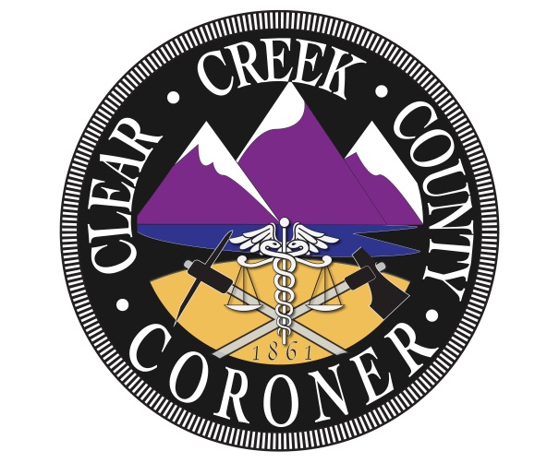

The mission of the Clear Creek County Coroner’s Office is to protect the interests of deceased individuals and the citizens of Clear Creek County by conducting independent investigations of deaths occurring within our jurisdiction. We determine the cause and manner of death, the identity of the decedent and provide notification to the legal next of kin with compassion, professionalism, and integrity.

Coroner Staff

Chris Hegmann
Coroner

Nichol Nelson
Chief Deputy Coroner

Kristi Morrell
Deputy Coroner

Alex Greenhagen
Deputy Coroner

Louis Greek
Deputy Coroner

2021 Clear Creek County Deaths

Total Deaths: 55

Gender:
- Male: 31
- Female: 24

Manner:
- Natural: 41
- Accidental: 7
- Suicide: 4
- Homicide: 1
- Pending final results: 2

Natural causes:
- Cardiac: 17
  - Heart failure: 9
  - Myocardial infarction: 4
  - Hypertension: 1
  - Hypertensive cardiovascular disease: 2
  - Severe vascular disease: 1
- Cancer: 10
  - Lung cancer: 3
  - Pancreatic cancer: 2
  - Ovarian cancer: 1
  - Prostate cancer: 2
  - Liver cell carcinoma: 1
  - Malignant neoplasm of uterus: 1
- Malnutrition: 2
- Respiratory failure: 1
- Alzheimer’s: 2
- Liver and kidney failure: 1
- Osteomyelitis: 1
- Acute gastroenteritis: 1
- Liver cirrhosis: 1
- Liver failure: 1
- Senile degeneration of the brain: 1
- Acute occlusive pulmonary thromboemboli: 1
- ALS: 1
- Hypoxic respiratory failure: 1

Suicide:
- Gunshot wound: 4

Homicide:
- Multiple gunshot wounds: 1

Accidental:
- Blunt force injuries: 3
- Subdural hematoma: 1
- Mechanical traumatic asphyxia and suffocation: 1
- Acute aortic rupture with dissection due to chronic methamphetamine use: 1
- Sever spine injuries: 1

Autopsies: 13

Hospice: 22

Deaths by month:
- January: 3
- February: 4
- March: 8
- April: 4
- May: 1
- June: 4
- July: 6
- August: 4
- September: 3
- October: 4
- November: 8
- December: 6

Deaths by age:
- 0-20: 1
- 21-30: 1
- 31-40: 4
- 41-50: 2
- 51-60: 10
- 61-70: 12
- 71-80: 9
- 81-90: 9
- 91+: 7

Jurisdiction:
- Idaho Springs: 12
- Georgetown: 6
- Empire: 4
- Evergreen: 7
- Dumont: 5
- Silver Plume: 1
- Unincorporated CCC: 16
- Transfer: 4

Local: 41
Visitor: 14

Trends and Observations

2021 was an odd year as the death rates decreased from 62 deaths in 2020 to 55 in 2021. Death rates may have decreased due to everyone being more cautious of their health and seeing a doctor more frequently.

The greatest number of natural deaths was contributed by cardiac events with a total of 17 deaths. This seems to be common throughout the years and has escalated more in 2021. In 2020 there were 14 out of 46 of natural deaths whereas 2021 there were 17 out of 41 of natural deaths.

The number of suicides has remained the same as 2020 with 4 in 2021. 2 out of 4 of the suicides are from those that resided out of the county. The difference with 2021 is that all suicides were caused by gunshot wounds to the head.

Accidental deaths have only changed by 1 as in 2020 there were 8 as of 2021 there were 7. The contribution to the greater number of accidental deaths had resulted in blunt force injuries which is common throughout the years.

In 2021 there was 1 homicide death that was due to multiple gunshot wounds. This is similar to 2020 as we had another homicide that was also due to multiple gun shot wounds.

Autopsies have increased to 13 in 2021 whereas there were 11 in 2020. The number of hospice deaths has stayed the same with 22, but shows a greater percentage in 2021 as there were not as many deaths as 2020.

In 2021 like past years there were still a greater number of male deaths compared to female deaths. There were 31 male deaths and 24 female deaths in 2021.

In 2021 the most deaths came out of March and November with both being 8. In 2020 the most deaths came out of September with a total of 11. The most common death by age was noticed to be 51-70 in 2021, which was the same for 2020.

Overall death rates have decreased in 2021, but death rates seem to exhibit similar aspects throughout the years.

