Clear creek county coroner’s office
Chris Hegmann, Coroner
2022
Annual report

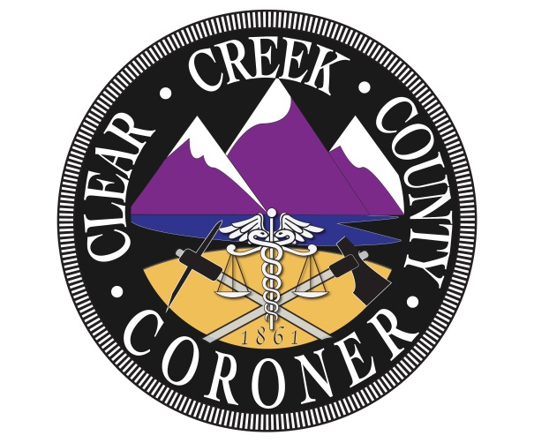

The mission of the Clear Creek County Coroner’s Office is to protect the interests of deceased individuals and the citizens of Clear Creek County by conducting independent investigations of deaths occurring within our jurisdiction. We determine the cause and manner of death, the identity of the decedent and provide notification to the legal next of kin with compassion, professionalism, and integrity.

Coroner Staff

Chris Hegmann
Coroner

Nichol Nelson
Chief Deputy Coroner

Kristi Morrell
Deputy Coroner

Alex Greenhagen
Deputy Coroner

Louis Greek
Deputy Coroner

2022 Clear Creek County Deaths

Total Deaths: 68

Gender:
- Male: 36
- Female: 32

Manner:
- Natural: 39
- Accidental: 21
- Suicide: 4
- Homicide:1
- Undetermined: 1
- Pending final results: 2

Natural causes:
- Cardiac: 12
  - Heart failure: 3
  - Myocardial Infarction: 1
  - Atherosclerotic cardiovascular disease: 3
  - Hypertensive cardiovascular disease: 2
  - Cardiac tamponade: 1
  - Hypertensive, atherosclerotic, valvular heart disease: 1
  - Congestive heart failure: 1
- Cancer: 9
  - Breast cancer: 2
  - Myeloid sarcoma:1
  - Lung cancer: 3
  - Pancreatic cancer: 1
  - Leukemia: 1
  - Brain tumor: 1
- Dementia: 5
- Acute bilateral pulmonary and intracardiac thromboemboli: 1
- Respiratory failure: 2
- COPD: 2
- Pulmonary emboli: 1
- Chronic kidney disease: 1
- Acute Bronchopneumonia: 1
- Cerebral Atherosclerosis: 1
- Cerebral vascular disease: 1
- Calorie protein malnutrition: 1
- Acute and subacute hepatic failure: 1
- Chronic hypoxic respiratory failure: 1

Suicide: 4
- Gunshot wound to head: 1
- Multiple drug toxicity: 1
- Multiple blunt force injuries: 1
- Carbon monoxide toxicity: 1

Accidental: 21
- Multiple blunt force injuries: 7
- Sepsis: 1
- Hypothermia: 2
- Acute CVA: 1
- Toxic effects of methamphetamine: 2
- Smoke inhalation: 1
- Traumatic brain injury: 1
- Kratom overdose: 1
- Fractured hip: 1
- Drowning: 1
- Multiple drug toxicity: 3

Homicide: 1
- Multiple gunshot wounds: 1

Autopsies: 27

Hospice: 19

Deaths by month:
- January: 5
- February: 6
- March: 5
- April: 3
- May: 5
- June: 7
- July: 11
- August: 3
- September: 7
- October: 7
- November: 4
- December: 5

Deaths by age:
- 0-20: 0
- 21-30: 5
- 31-40: 6
- 41-50: 12
- 51-60: 5
- 61-70: 13
- 71-80: 15
- 81-90: 6
- 91+: 6

Jurisdiction:
- Idaho Springs: 18
- Georgetown: 7
- Empire: 2
- Evergreen: 13
- Unincorporated Clear Creek County: 19
- Silver Plume: 1
- Downieville:1
- Dumont:1
- Transfer: 6

Local: 46
Visitor: 22

Trends and Observations

2022 was a diverse, busy year compared to previous years. Clear Creek County Coroner’s Office encountered various causes of death that were out of the ordinary. Accidental deaths went up three times compared to previous years which, contributed to an increase of autopsies. Non-county residents accounted for 32% of all cases in 2022. The quantity of deaths in 2022 increased as well as the number of autopsies as there were more accidental deaths and lack of medical records available for numerous individuals.
In 2022, there was an increase in the amount of deaths with a total of 68; as compared to 2021, there were 55. This equals a 19% increase in case load for the Clear Creek County Coroner’s Office. Similar to previous years the manner of death that was the largest was natural. There was a drastic increase in accidental deaths in 2022, where suicide deaths were similar compared to former years.
The highest number of natural deaths was contributed by cardiac events with a total of 12 deaths, which is comparable to past years. Cancer deaths have seemed to stay the same throughout the years only fluctuating by one or two deaths a year. In 2021, there were a total of 41 natural deaths whereas 2022, there were 39.
The number of suicides has seemed to stay consistent throughout the last three years with a total of 4. All of the suicides from 2022 are from those that did not reside in Clear Creek County. In 2021 all the suicides were caused by gunshot wounds, while in 2022 they were each different causes of death.
Accidental deaths have increased significantly with a total of 21 in 2022, as compared to 2021 with only 7. Resembling 2021, the greatest number of accidental deaths was caused by multiple blunt force injuries. There was a large difference in drug related accidental deaths in 2022 with a total of 5, as for 2021 there was only one drug related accidental death. 2022 was a unique year as the Clear Creek County Coroner’s Office responded to unusual deaths. For example, an all-terrain vehicle crash resulting in two deaths, a tesla catching on fire resulting in one death, and two hypothermic deaths in one home.
In 2022 there was one homicide death that was due to multiple gunshot wounds. This has been a parallel trend the last three years as in 2020 and 2021 there was one homicide from multiple gunshot wounds in each year. There was also 1 undetermined cause of death in 2022, as the decedent was found four months after the individual’s disappearance in Clear Creek County.
Autopsies have greatly increased from 7 in 2021, to 27 in 2022. This increase is due to a lack of medical records as individuals were not going to medical facilities due to COVID-19 as well as the increase in accidental deaths within the county. There was a total of 19 hospice deaths in 2022 as compared to 22 in 2021.
In 2022, there was an increase in the number of deaths of people that did not reside in the county. A total of 22 out of 68 deaths which accounts for 32% of the total deaths in the county. Compared to 2021, there were 14 deaths of those that did not reside in the county which was 25% of the total deaths in the county. There has been a trend with an increase of non-local deaths throughout the years.
2022 was similar to former years in terms of the decedents sex as there were still more male deaths then female deaths. There were 32 female deaths and 36 male deaths in 2022. In 2022, the most deaths occurred during July, while previous year’s most deaths occurred in March, September and November. The most deaths by age in 2022 exhibited to be 41-50, 61-70 and 71-80. The average age of deaths for 2022 was calculated to be 61. The deaths by age compared to the deaths by age in 2021 are similar as the most deaths by age were 51-60 and 61-70.
Overall, death rates have increased within Clear Creek County in 2022. Each year seems to exhibit similar trends in deaths except for accidental deaths has exponentially increased. There has also been a noticeable increase in the number of deaths of those that do not reside within Clear Creek County. The number of deaths that occurred in 2022 may have increased due to the end of the quarantine and restrictions, increase in travel and the decrease of receiving and access to healthcare.

