Clear creek county coroner’s office
Chris Hegmann, Coroner
2023
Annual report

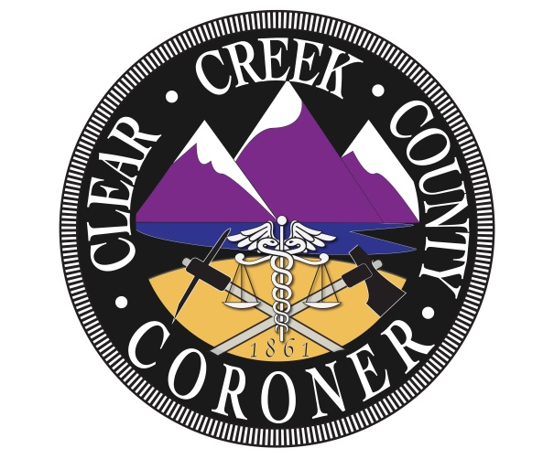

The mission of the Clear Creek County Coroner’s Office is to protect the interests of deceased individuals and the citizens of Clear Creek County by conducting independent investigations of deaths occurring within our jurisdiction. We determine the cause and manner of death, the identity of the decedent and provide notification to the legal next of kin with compassion, professionalism, and integrity.

Coroner Staff

Chris Hegmann
Coroner

Nichol Nelson
Chief Deputy Coroner

Alex Greenhagen
Deputy Coroner

Louis Greek
Deputy Coroner

2023 Clear Creek County Deaths

Total Deaths: 53

Gender:
- Male: 37
- Female: 15

Manner:
- Natural: 33
- Accidental: 13
- Suicide: 6

Natural causes:
- Cardiac: 14
  - Heart failure: 4
  - Congestive heart failure: 4
  - Coronary artery disease: 2
  - Hypertension: 2
  - Dissection of aorta: 1
  - Hypertensive cardiovascular disease: 1
- Cancer: 5
  - Pancreatic cancer: 1
  - Leukemia: 1
  - Kidney cancer: 1
  - Malignant neoplasm of the brain: 1
  - Head and neck squamous cell carcinoma: 1
- Chronic alcohol abuse: 2
- Acute on chronic occlusive bilateral pulmonary thromboeboli: 1
- Acute occlusive bilateral pulmonary thromboemboli: 1
- Nontraumatic intracranial hemorrhage: 1
- Alcoholic cirrhosis of the liver: 1
- Lewy body dementia: 1
- Acute lobar pneumonia: 1
- Complications due to fungal infection of the lung: 1
- Seizure due to ethanol withdrawal: 1
- Renal failure: 2
- Chronic respiratory failure with hypoxia: 1
- Acute on chronic hypoxic respiratory failure: 1
Suicide: 6
- Gunshot wound to the oral cavity: 2
- Gunshot wound to the head: 3
- Vehicle assisted ligature decapitation: 1

Accidental: 13
- Blunt force injuries: 6
- Methamphetamine intoxication: 2
- Hypothermia: 1
- Toxic effects of fentanyl: 1
- Fentanyl and ethanol intoxication: 1
- Complications including emboli of the lungs:1
- Fentanyl, para- flurofentanyl and methamphetamine intoxication: 1

Autopsies: 20

Hospice: 11

Deaths by month:
- January: 4
- February: 2
- March: 4
- April: 6
- May: 3
- June: 3
- July: 5
- August: 6
- September: 6
- October: 5
- November: 2
- December: 7

Deaths by age:
- 0-20: 1
- 21-30: 4
- 31-40: 5
- 41-50: 2
- 51-60: 8
- 61-70: 7
- 71-80: 14
- 81-90: 8
- 91+: 3

Jurisdiction:
- Idaho Springs: 11
- Georgetown: 2
- Empire: 5
- Evergreen: 5
- Dumont: 7
- Lawson: 1
- Silver Plume: 2
- Unincorporated CCC: 14
- Transfer: 6

Local: 41
Visitor: 11

Trends and Observations

Clear Creek County Coroner’s Office had a total of 53 deaths, which is fewer than the previous year. The cases that the office encountered were demanding. 20 out of the 53 were autopsied, accounting for 38% of the cases. The investigations were more in-depth as there was a trend of limited medical records available, multiple accidental deaths, and questionable suicides.
2023 was similar to past years with the largest manner of death as natural. Hospice cases declined with a total of 11 where there were 19 in 2022. Suicides increased to 6 compared to 2022 and in 2021 there were 4. There were 13 accidental deaths in 2023, which is a decrease from 2022 with 21. Non-county residents accounted for 21% of the cases for 2023.
Comparable to the past years cardiac deaths were the highest number of natural deaths with a total of 14. Cancer deaths were the second largest with 5 which was a decline from 2022 where there were 9. Compared to 2022 natural deaths went down by almost 50%.
Suicide deaths have increased in 2023 with a total of 6 compared to 2022 there were 4. 4 out of the 6 suicidal deaths were from those that did not reside in Clear Creek County. In 2022 suicides were completed by different methods, while in 2023 the majority were gun-related deaths. Clear Creek County Coroner’s Office conducted autopsies on two of the suicide cases as they both were questionable situations.
Accidental deaths decreased from 2022 where there were 21 and in 2023 there were 13, which is still larger than past years. Similar to 2022 the largest number of accidental deaths were by blunt force injuries with a total of 6. There was an increased trend in drug overdoses as 4 out of the 13 accidental cases were related to drugs. Within those drug overdoses there were 3 that were due to fentanyl.
Autopsies have nearly stayed the same as in 2022 39% of the cases were autopsied and in 2023 38% were autopsied. The Coroner’s office has noticed a trend of limited medical records throughout the years therefore increasing the number of autopsies performed. There were a total of 11 hospice deaths in 2023 where there were 19 in 2022 and 22 in 2021.
In 2023, 21% of the total cases were out of county residents with a totaling 11 cases. This is a decrease from 2022 that exhibited 32% of the total cases that were out of county residents. There had been an increase in the trend of out of county resident deaths, but as of 2023 it seems to have declined.
2023, like many previous years the deaths by gender has shown that there are still more male deaths then female deaths. There were 15 female deaths and 37 male deaths in 2023. In 2023, the most deaths occurred in December with 7 followed by April, August, and September with 6. In 2022, the most deaths occurred in July. The most deaths by age were in the range of 71-80 with 14.
Overall, the number of cases has decreased within Clear Creek County in 2023. The caseload has been extensive as each case included more investigative efforts. The number of suicidal deaths has increased and there was still a large amount of accidental death in 2023. The number of autopsies for the last two years have exponentially increased from previous years and is related to the lack of medical records on individuals and the increase in accidental deaths.

