Clear creek county coroner’s office
Chris Hegmann, Coroner
2024
Annual report

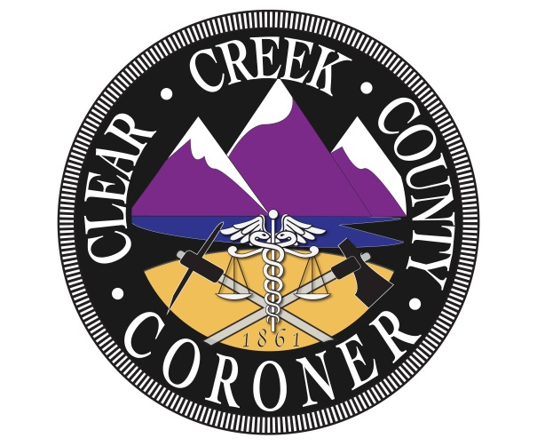

The mission of the Clear Creek County Coroner’s Office is to protect the interests of deceased individuals and the citizens of Clear Creek County by conducting independent investigations of deaths occurring within our jurisdiction. We determine the cause and manner of death, the identity of the decedent and provide notification to the legal next of kin with compassion, professionalism, and integrity.

Coroner Staff

Chris Hegmann
Coroner

Nichol Nelson
Chief Deputy Coroner

Alex Greenhagen
Deputy Coroner

Louis Greek
Deputy Coroner

2024 Clear Creek County Deaths

Total Deaths: 64

Gender:
- Male: 44
- Female: 18

Manner:
- Natural: 36
- Accidental: 15
- Suicide: 3
- Homicide: 1
- Undetermined: 2
- Pending: 6
- Cremated Remains: 2

Natural causes: 36
- Cardiac: 12
  - Heart failure: 1
  - Congestive heart failure: 2
  - Consistent with myocardial infarction: 3
  - Hypertensive and atherosclerotic cardiovascular disease
  - Myocardial fibrosis
  - Unspecified atherosclerosis of arteries
  - Acute thrombus in the left anterior descending coronary artery complicating coronary atherosclerosis
  - Hypertension
  - Cardiac hypertrophy
- Cancer: 11
  - Pancreatic cancer
  - Breast cancer
  - Colon cancer
  - Hepatocellular carcinoma
  - Unspecified B cell lymphoma
  - Ovarian cancer
  - Glioblastoma multiforme
  - Prostate cancer: 2
  - Bladder cancer
  - Malignant melanoma mets
- Pulmonary: 6
  - Chronic respiratory failure
  - Bronchopneumonia
  - Acute bilateral pulmonary embolism with core pulmonale
  - Acute occlusive pulmonary bilateral thromboemboli
  - Complications of chronic obstructive pulmonary disease
  - Acute on chronic respiratory failure
- Diabetic ketoacidosis
- Alzheimer’s disease
- Diabetes mellitus
- Chronic kidney disease stage 5
- Complications due to alcohol abuse
- Wernicke’s Encephalopathy
Suicide: 3
- Gunshot wound to the head
- Gunshot wound to the chest
- Through and through gunshot wound to the head

Accidental: 15
- Blunt force injuries: 9
- Combined toxic effects of fentanyl and ethanol
- Complications of recent femur fracture
- Electrocution
- Persistent sepsis
- Combined toxic effects of fentanyl, oxycodone, hydroxyzine and promethazine
- Oxycodone and gabapentin intoxication

Undetermined: 2
- Pulmonary neoplasm
- Hypothermia

Autopsies: 26

Hospice: 18

Deaths by month:
- January: 5
- February: 8
- March: 4
- April: 5
- May: 5
- June: 5
- July: 2
- August: 7
- September: 0
- October: 5
- November: 10
- December: 8

Deaths by age:
- 0-20: 1
- 21-30: 4
- 31-40: 7
- 41-50: 6
- 51-60: 6
- 61-70: 10
- 71-80: 16
- 81-90: 11
- 91+: 1

Jurisdiction:
- Idaho Springs: 14
- Georgetown: 5
- Empire: 5
- Evergreen: 12
- Dumont: 3
- Silver Plume: 1
- Unincorporated CCC: 16
- Transfer: 8

Local: 43
Visitor: 19

Trends and Observations

Clear Creek County Coroner’s Office acquired 64 cases in 2024, two of which were cremated remains found and reported to the Office, and a Deputy Coroner responded to retrieve and investigate. There was an increase in cases in 2024, with a total of 64, compared to 2023, with 53. Similar to previous years, the cases were demanding, as 26 cases were autopsied, accounting for 41% of cases. 2024 autopsied cases had a 3% increase from 2023 autopsied cases.
Natural death cases like in previous years were still the largest manner of death totaling 36 cases. Hospice cases increased with a total of 18 compared to 2023 when there were 11. Suicides decreased from 2023 with a total of 6 to 3 in 2024. Accidental deaths have had a slight increase as there were 15 in 2024 and 13 in 2023. Unlike other years Clear Creek County Coroner’s Office received 2 undetermined cases and 1 homicide. Non-county residents accounted for 31% of the 2024 cases.
Cardiac deaths were the highest contributing cause of death for natural deaths with a total of 12. There were 11 cancer deaths, 7 were pulmonary-related deaths and 6 were miscellaneous. In contrast to 2023, there were 14 cardiac deaths, 5 cancer deaths, 6 pulmonary deaths, and 7 miscellaneous. Reviewing previous years cardiac deaths and pulmonary deaths are consistent while cancer deaths seem to fluctuate each year.
Suicide deaths have decreased in 2024 with 3 while in 2023 there were 6. Comparable to 2023, all suicidal deaths in 2024 were gun-related. 2 out of the 3 suicides were from individuals who resided within Clear Creek County. 1 out of the three suicides was autopsied due to the unique situation.
Accidental deaths increased to 15 in 2024 from 13 in 2023. Analogous to 2023, blunt force injuries contributed to the foremost amount of accidental deaths with 9. There were 3 accidental deaths related to drug overdoses with 2 of them containing fentanyl.
There was 1 homicide in 2024 that required further investigation including a forensic anthropologist due to the circumstances. Clear Creek County Coroner’s Office encountered 2 undetermined cases that led to extensive investigation and resources, but unfortunately could not conclude a definite manner of death.
There were 26 autopsies in 2024 and 20 in 2023. The number of autopsies has gone up by 2% with 41% of cases being autopsied in 2024 and 39% in 2023. Autopsies have increased similarly to previous years due to an increase in accidental deaths and a lack of medical records or information in medical records.
In 2024, there were 19 out-of-county resident deaths attributing for 31% of the total cases. 2024 out-of-county resident deaths increased by 10% from 2023 which was 21%. The manner of death associated with the largest amount of deaths for out-of-county residents is accident with 9 out of the 15 total accidental deaths.
The number of deaths by gender has equivalent results to previous years with more male deaths than female deaths. In 2024 there were 44 male deaths and 18 female deaths with 71% being male. In 2023 there were 37 male deaths and 15 female deaths with 70% being male deaths. Male deaths have been reported larger than female deaths even back in 2018.
The number of deaths by month in 2024 showed that November had the uttermost amount with 10 followed by February and December with 8. In 2023, most deaths occurred in December. Unlike previous years there was a month in 2024 where there were no deaths that month being September. The most deaths by age are consistent with 2023 being from 71-80 years old with 18.
To conclude, the number of cases in Clear Creek County has increased in 2024. 2024, showed many similarities to previous years including the increase in autopsies performed. There has been an increase in out-of-county resident deaths which in turn increases the number of cases in Clear Creek County. 2024, exhibited differences from previous years such as a homicide and 2 undetermined cases. Clear Creek County Coroner’s Office will continue to use all resources available to determine cause and manner of death.

